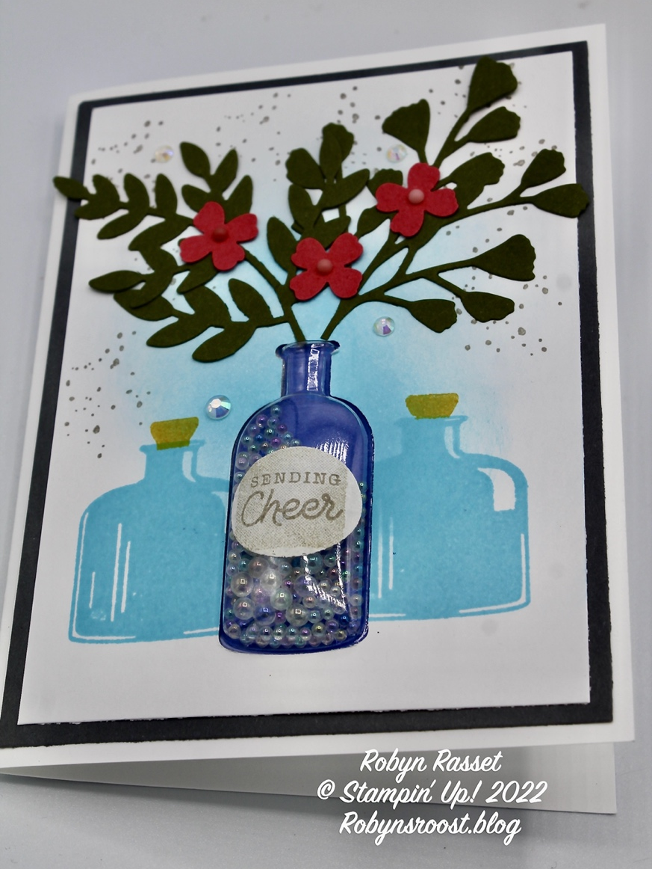

Stamps:
Bottled Happiness
Watercolor Shapes
Forever Fern
Gumball Greetings (Inside)
Ink:
Tahitian Tide
Gray Granite
Sahara Sand
Crushed Curry
Paper:
Basic White Thick 8 ½” x 5 ½” Scored at 4 ¼’
Basic Gray 4” x 5 1/4”
Basic White 3 ¾” x 5”
Mossy Meadow 3 ¼” x 5”
Orchid Oasis 2” x 3”
Sweet Sorbet 1”x 5”
Accessories
Vintage Bottle Shaker Domes
2022-2022 In Color Dots
Vintage Bottle Punch
Small Flower Punch
Effervescent Bubbles
Iridescent Rhinestones
Hat Builder Dies
Forever Flourishing Dies
Label Sticker
Blending Brush
Directions:
- Use blending brush to add Tahitian Tide ink to center of 3 ¾” x 5” white card stock. Punch Vintage Bottle going as far up from bottom as punch will reach.
- Stamp two short bottles with Tahitian Tide ink, one on each side of punch out. Add corks with Crushed Curry ink, using a post it note to mask bottle.
- Stamp speckles from Forever Fern with Gray Granite ink.
- Remove top adhesive layer from Vintage Shaker Bottle and lay the white layer over the plastic bottle, line up and push down to adhere.
- Place a scoop of Effervescent Bubbles into the plastic shaker bottle. Remove adhesive back and place the 2” x 3” Orchid Oasis cardstock over to seal bubbles. Add adhesive to entire back and layer onto the Basic Gray 4” x 5 ¼” cardstock. Adhere to card base.
- Die cut 2 largest leaf dies from Forever Flourishing Dies from Mossy Meadow cardstock. Clip ends as necessary to fit into bottle and adhere to card.
- Punch flowers from Sweet Sorbet cardstock (single or double as desired) add to leaves.
- Add 4 Iridescent Rhinestones to background and 3 In Color Dots to flower centers.
- Stamp Watercolor shape with Sahara Sand ink onto Label Sticker. Stamp greeting from Bottled Happiness onto label. Die cut with oval die from Hat Builder Die set. Stick to bottle.
- Stamp inside with Watercolor Shape in Sahara Sand ink then stamp greeting from Gumball Greetings with Tahitian Tide ink.

