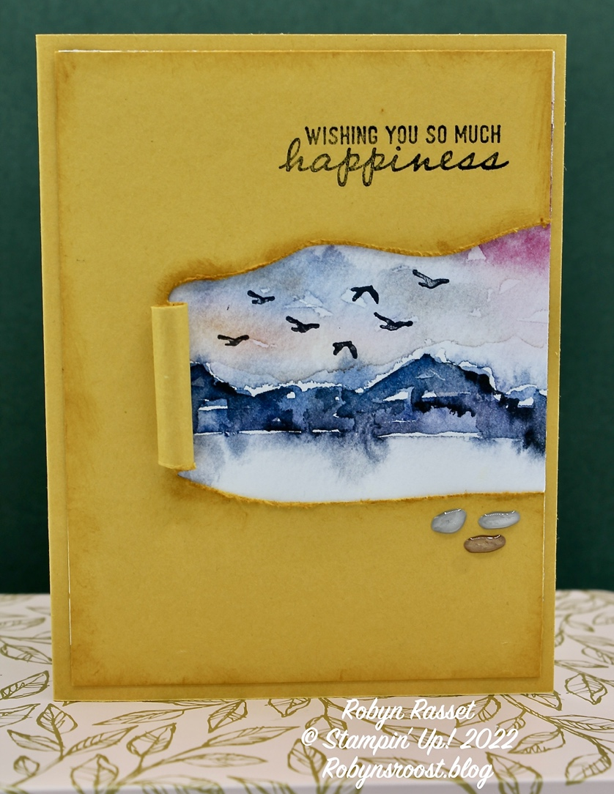
Stamps:
On the Horizon
Through it Together
Ink:
Tuxedo Black
Bumblebee
Paper:
Bumblebee 8 ½” x 5 ½” Scored at 4 ¼”
Bumblebee 4” x 5 ¼”
Horizon DSP 4” x 6”
Horizon DSP 1” x 5 ¼”
Very Vanilla 4” x 5 ¼”
Accessories
Horizon Dies
Pebbles Shapes
Sponge Dauber
Distressing Tool
Bone Folder
Directions:
- Die cut the 4” x 5 ¼” with the two long dies from the Horizon Die set. Place them so that the peeled back scroll with be in the center of the card, using about a third of the space.
- Use a distressing tool to distress the edges of the die cut areas.
- Sponge the edges of the cut areas and the edges of the layer.
- Use a bone folder and soften the fibers on the part that will be rolled up. Continue working the paper, rolling and unrolling until satisfied. Then glue to the edge.
- Test the piece of designer paper to position where wanted. When satisfied, cut to fit, and add any stamping. Glue to peekaboo layer.
- Finish gluing and add Pebbles.
- Add strip of DSP to Very Vanilla, stamp greeting and add to inside of card.

