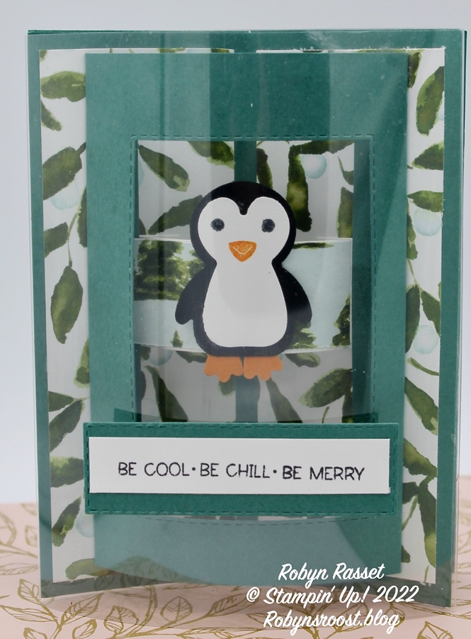
Stamps:
Penguin Place
Ink:
Tuxedo Black - Pumpkin Pie - Tahitian Tide
Paper:
Base 4 pieces 4 ¼” x 5 ½” scored at 2 1/8”
DSP 4 pieces 1 7/8” x 5 1/4”
Tab ¾” x 2 ½” Score at ½” on each end
Tab cover DSP ¾” x 1 ¾”
Front & Back Bendi 4 1/4” x 5” scored at ½” & 4 ½”
Greeting Die cut 1” x 3”
Greeting white ½” x 2 ¾”
White Back 3” x 4 ¾”
Black for penguin punch out
White for penguin punch out
Pumpkin Pie for penguin punch feet
Window Sheet 5 ½” x 5 ¼” score hard ½” on each tall side
Accessories
Stitched Rectangle Dies
Penguin Punch
Liquid Glue
Tear & Tape
Directions:

- Use bone folder to crease all 4 base pieces. Add DSP to both sides of one base.
- Cover the tab with DSP. Use a bone folder to curve the tab. Add glue to tabs and adhere to card base that you just prepared, centering over the fold and slightly above halfway up and down. Do this with the card flat.
- Take one of the Bendi pieces and use a bone folder to curve. Die cut an opening using the Stitched Rectangle Die. (or other die). Re-curve after die cutting if needed.
- Punch out penguin, stamp eyes and bill and adhere layers. Adhere to the tab with two or three glue dots in a line from the neck to the feet.
- Add the die cut Bendi layer to the card front. Add liquid glue to the tabs lay base flat and center over the fold.
- *optional window sheet* Fold window sheet on the score lines and burnish with bone folder. Add Tear & Tape to tab. Snip off a triangle from each corner. Remove tape cover and adhere by hooking over the edge of the card front. Repeat on the other side, laying the card open and flat to be sure that it will close to fit in envelope.
- With the 3 remaining bases, fold first one in half, add liquid glue to one outside. Fold the second and add to the first. Add glue on one side of this one and add the third one.
- Lay these bases on the table with the middle one open flat on the table and the other two folded in half. Add liquid glue to one side of the card front and adhere to the base. Add glue to the other half of the base and lay flat to adhere.
- For the back greeting, stamp the words and images on the back layer. Use a bone folder to curve. Adhere to the other Bendi piece. Add liquid glue to tabs and add to the back of the card.
- Stamp front greeting and layer onto die cut cardstock. Use glue dots to center on front of window sheet. If not adding window sheet, glue to the sides of the Bendi frame below the penguin.

