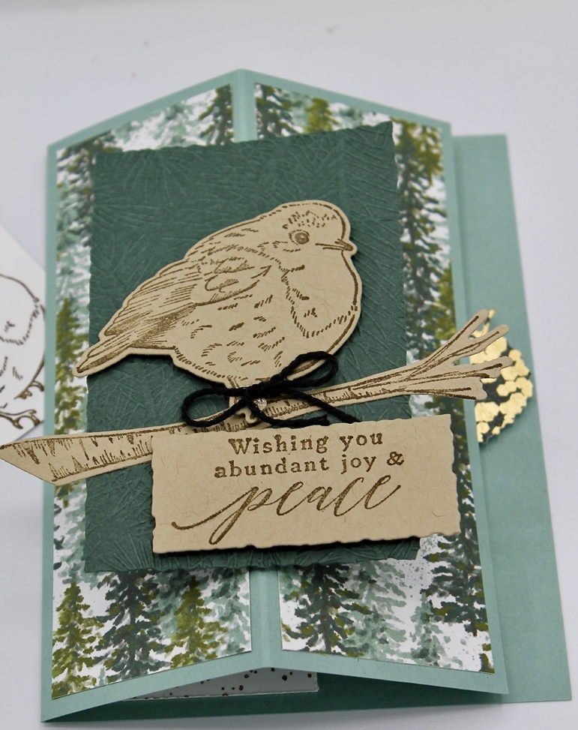

Stamps:
Perched in A Tree
Ink:
Soft Suede
Paper:
Soft Succulent 8 ½” x 5 ½” scored at 2 1/8” & 4 ¼”
Boughs of Holly DSP 2 pieces 1 7/8” x 5 ¼”
Evening Evergreen 2 ½” x 4”
Basic White 2 1/8” x 5 ¼”
Metallic & Shimmer scrap for leaf
Crumb Cake 4 ½” x 4” for die cutting
Soft Succulent scrap for punching 2 support circles
Accessories
Aspen Tree Dies
Deckled Rectangle Dies
Dimensionals
Wintry 3D Embossing Folder
1 ½” Circle Punch
Directions:
- Fold and burnish score lines.
- Adhere the two long decorative strips as shown.
- Die cut the Evening Evergreen layer and then emboss with the pine boughs.
- Stamp bird, branch and greeting with Soft Suede ink on Crumb Cake cardstock and then die cut.
- Stamp the inside white strip and adhere.
- Adhere the branch to the evergreen layer.
- Using dimensionals adhere the bird and greeting.
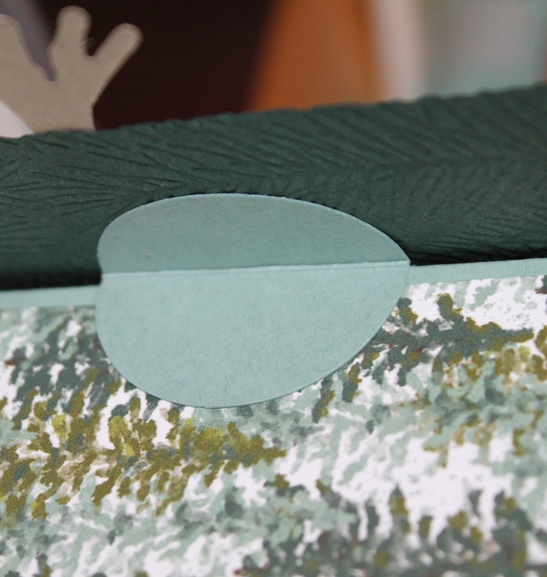
- Punch 2 – 1 ½” circles of Soft Succulent, score and fold in half. Glue to the back of the evening evergreen layer, folded with the two folded circles butted up against each other. Then adhere one on each side of the fold on the front of the card to support the bird layer and make it stand out when the card is opened. The photo below shows one support and the other will be on the other side.
- Adhere the leaf to the inside right edge with a dimensional as a stopper to hold the card open when standing.

